Customer Support Features:

Implement a ticketing system within ERPNext to track and manage customer support requests.

Allow users to create and manage support tickets directly from the ERPNext interface.

Ensure that tickets can be categorized, assigned, and tracked for efficient resolution.

* <https://docs.erpnext.com/docs/user/manual/en/support>
* <https://youtu.be/_x6YGuwEMeo?si=8fV1zLsleiiuoJaB>

Customer support and maintenance is at the heart of any successful business. With ERPNext, you track all incoming customer requests and issues and respond to them quickly. The database of incoming queries will also help you to identify the biggest opportunities for improvements.

You can track incoming queries from your email using Support Tickets. You can keep track of Customer Issues linked with a specific Serial No and respond to them based on their warranty and other information. You can also make Maintenance Schedules for Serial NOs and keep a record of all Maintenance Visits made to your Customers.

**Implement a ticketing system within ERPNext to track and manage customer support requests**.

Ticket Management

* Issue Types
* Issues
* Response Details
* Resolution Details
* Automation

The Support Module in ERPNext helps you keep a record of all the support request you receive from clients. This intern will help all support agents in your organization of a quick help to the clients who needs it. Customer can rise various issues or Tickets for various products or service related reasons. ERP next allows us to manage the entire journey of an issue or ticket from being raised by a client to the final resolution. It is important to channel such issue through the right workflows. Issues can arise from different sources like phone calls or emails or even social media. Keeping track of information for each issue and recording it. Make sure that all relevant details are accessible easily so that they can be resolved faster.

There can also be situations where certain issues cannot be solved by support agents or support engineers and might need the involvement of other engineers and accountants. In such cases, separate task need to be created. We can even analyse issues and identify patterns so that overall changes can be made in products and services, thus improving the overall customer experience. We can automate certain tasks like assigning tickets to write support agents, auto closing tickets after a certain period of inactivity.

Let's see how ERP Next helps to streamline customer support :

Let's first see how we can create an issue type. To open the issue type list, navigate from Home to the Support module and go to Issue section.

**Issue:**

**An Issue is an incoming query from a Customer, usually via email or from the**Contact**section of your website.**

Tip: A dedicated support Email Address is a good way to keep track of incoming queries.

**Issue Type:**

**Issue Type is useful for tagging and classifying Issues.**

Classifying Issues helps in assigning the concerned team members to specific Issues. Examples of Issue Types can be: 'Functional', 'Technical', 'Hardware', etc. So engineers can be assigned to technical or hardware issues and consultants would be assigned to address functional issues.

To open the issue type list, navigate from Home to the Support module and go to Issue section.

**Home > Support > Issues > Issue Type**

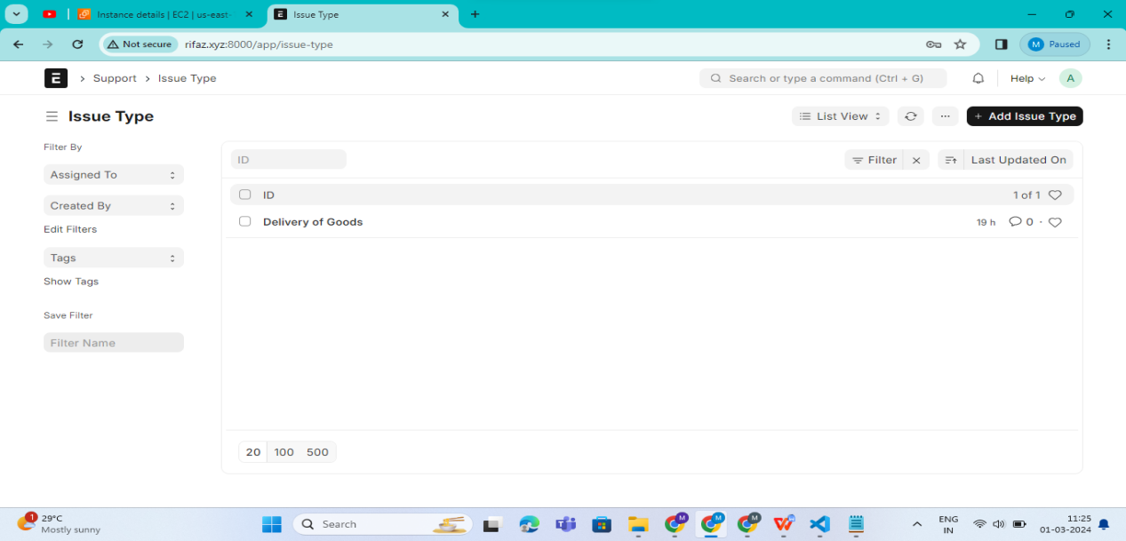

Here we can see any issue types already created and add a new one by clicking on Add Issue Type button. Here when we open the document, we can first name this issue, type and then add a description. For example, lets name this “Product Exchange” and add the description as “All issues raised by customers related to Product Exchange”. Once done, we can save this issue type.

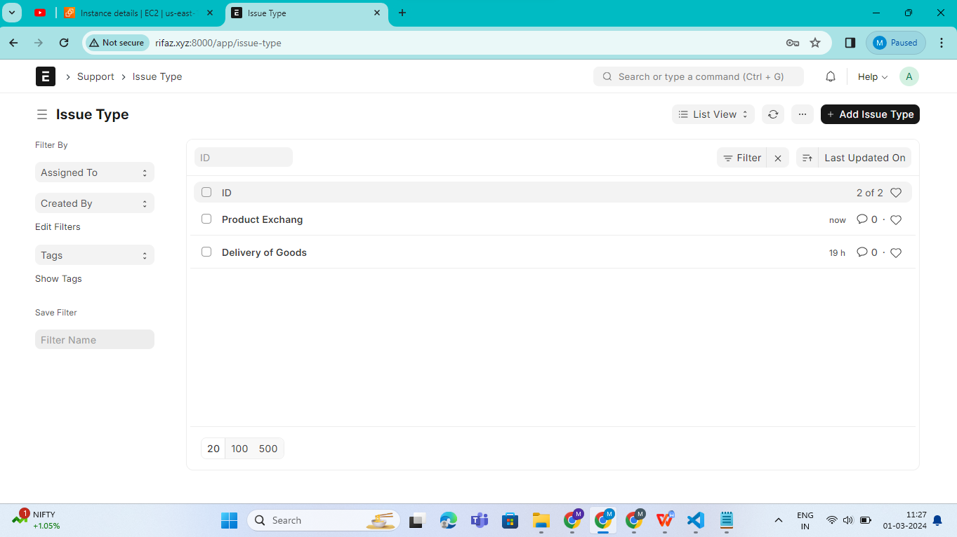

1. **Prerequisites**

Before creating and using Issues, it is advised that you create the following first:

* Customer
* Email Account

1. **How to create Issue**

Issues are automatically created if you use the ****append to feature**** in [Email Account](https://docs.erpnext.com/docs/v13/user/manual/en/setting-up/email/email-account" \l "32-incoming-email-accounts).

You can also create an Issue manually, to do that:

1. Go to the Issue list, click on New.

2 .Enter the Subject, Raised By, and a description of the Issue.

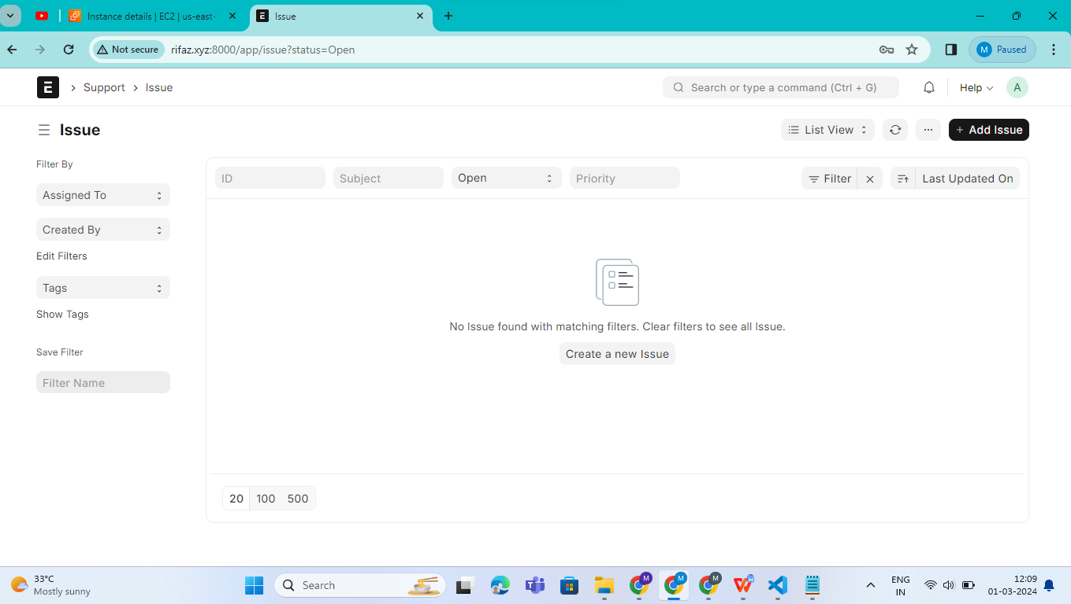

When we open a new issue document, we can see that we will first have to define a subject for that issue. Let's write delay in delivery of goods as the subject. Next we can pick the priority of this issue. Let's set it as medium. Then we will add customer details and select the issue type we just created. Lastly, in this section we can add the email of the person who has raised this issue. For example, if the customer we selected has raised the issue in the detailed section, we can add any details and the description of the issue raised. The Response detail section records details about when this issue was first responded to. When a support team member responds to this issue, the date and time are recorded here.The Resolution details section shows the opening and closing dates and times for this issue. Since this issue status is still open, it will only show the opening date and time. We can even add resolution details here. When we mark the issue as closed or resolved in the reference section, we can tag a lead project and add contact details for reference. We can even add an email account here.

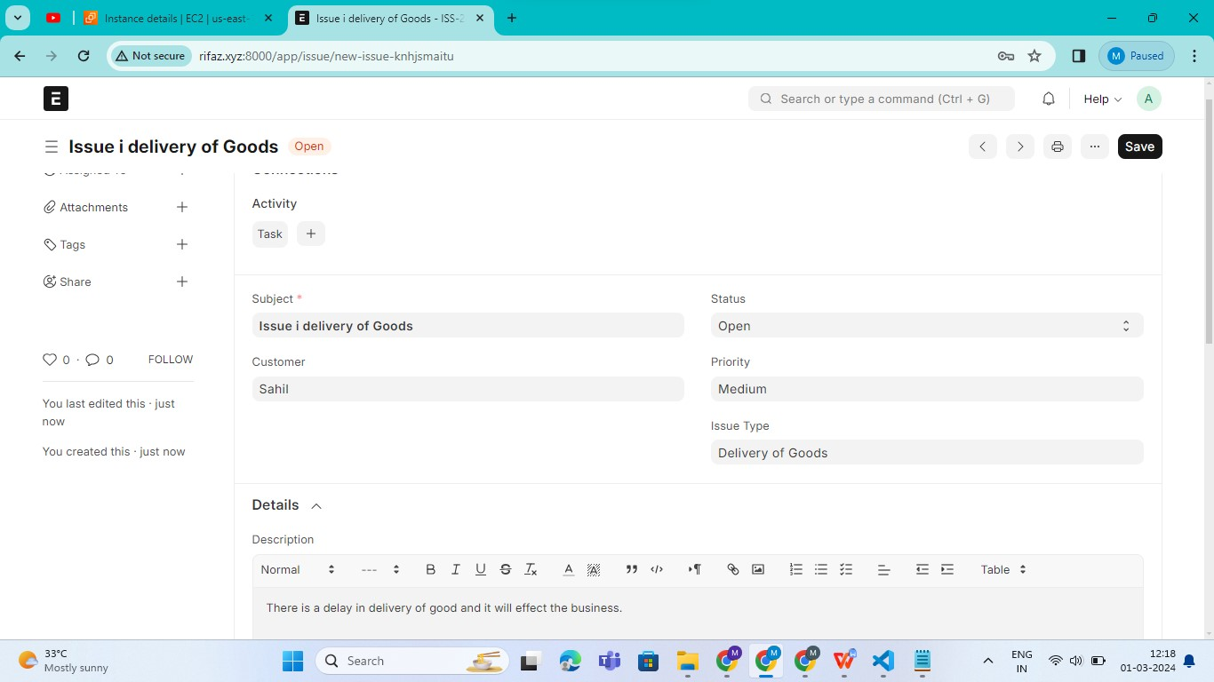

This is how we add the issue.